Name: YOUR NAME HERE (Note that there are three pages!)

**Q1: Lambda in ridge and lasso regression**

1. What is the potential range of lambda?
2. What is true about ridge vs lasso regression when lambda = 0?
3. As lambda gets bigger, what happens to the coefficients? How does this differ between ridge and lasso?
4. What is meant by “sets of coefficients” associated with lambda?

Reminder of function that is minimized in each method:

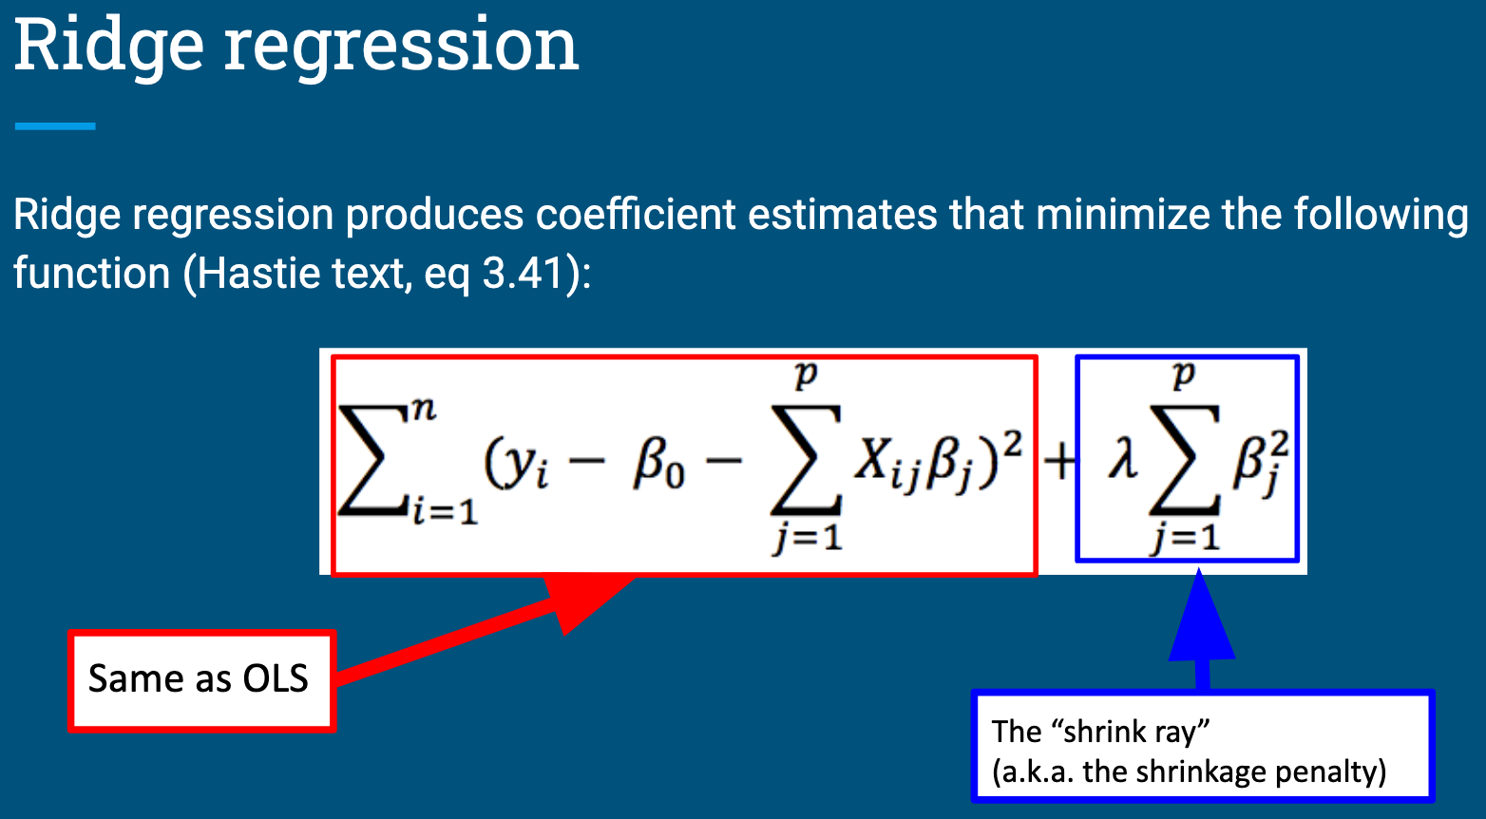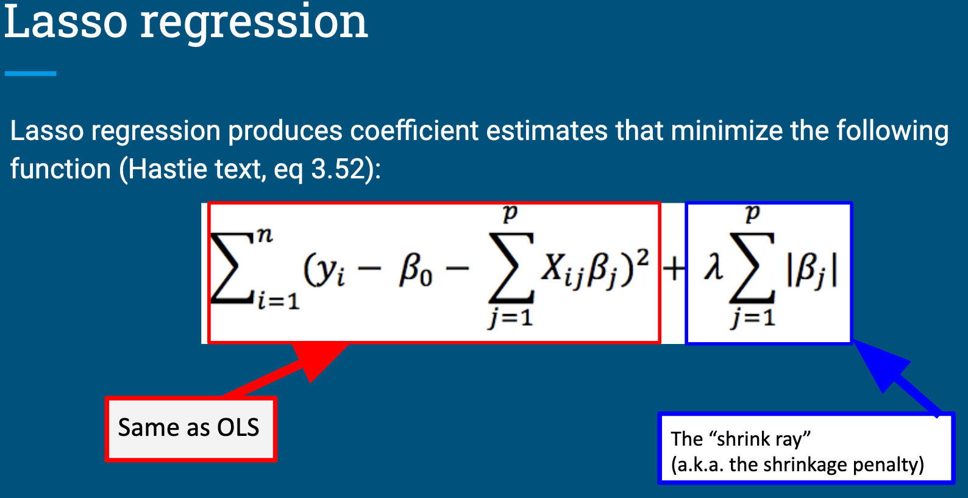

There are questions on the next page – keep going!

**Q2: The glmnet() function**

The answers to the following questions can be found in the glmnet documentation. You can find this by installing the package and typing ?glmnet into the console or by searching online.

There is also a nice introduction to using the package maintained by the developers: <https://glmnet.stanford.edu/articles/glmnet.html> . This may help with understanding how to apply the demonstrations in the async to the problem set.

1. The glmnet() function in the glmnet package can fit both lasso and ridge regression models. Which one does the function perform by default? What change do you need to make if you want to perform the non-default option?
2. The first argument in the function is ‘x’. What should you put here and what form does it need to be in?
3. The second argument in the function is ‘y’. What should you put here and what form does it need to be in?
4. The third argument in the function is ‘family’. What is the default of this? When would you need to change it?
5. By default, how many sets of coefficients will be evaluated? What change would you need to make if you wanted to evaluate 500 lambdas?